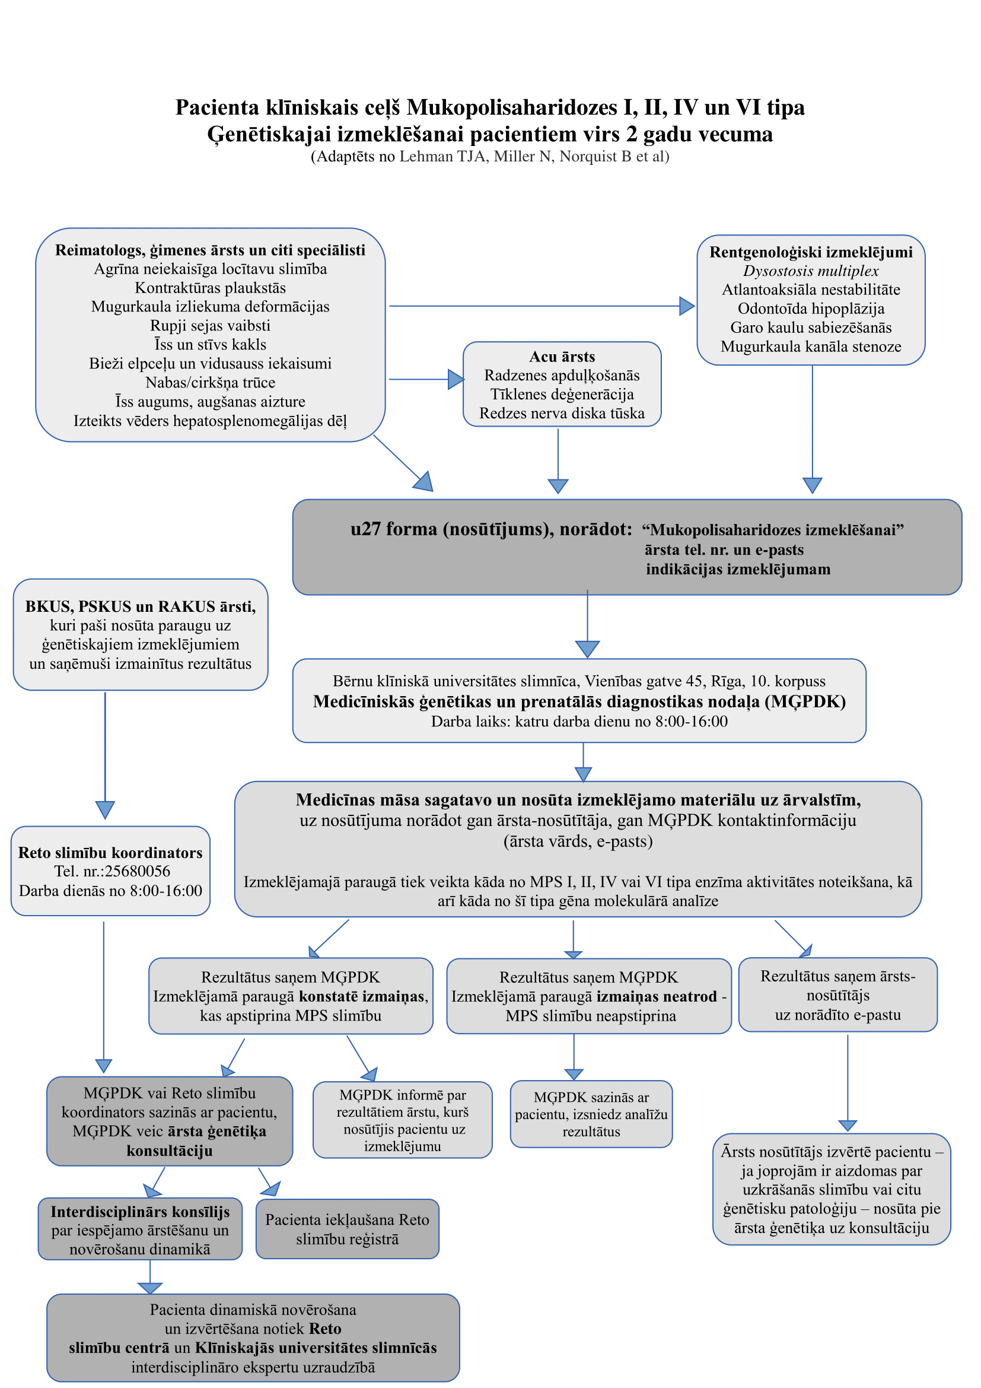
(Adaptēts no Lehman TJA et al., Rheumatology (Oxford) 2011; 50 (suppl_5): v41-v48)

